Tools for troubleshooting
Assignment
1. List three real-life scenarios where a multimeter would be used to troubleshoot a computer or smartphone issue, and explain in one line how the multimeter helps in each case.
Answer:
• Scenario 1: Smartphone or Laptop Charging Port Troubleshooting
Explanation: The multimeter measures the DC voltage output across charger pins and battery connectors to verify whether adequate power is reaching the motherboard.
• Scenario 2: Motherboard Short Circuit Detection
Explanation: The multimeter uses continuity or resistance mode to detect short circuits between power rails and ground, pinpointing damaged capacitors or MOSFETs.
• Scenario 3: Desktop Power Supply Unit (PSU) Voltage Verification
Explanation: The multimeter measures individual pin voltages (+12V, +5V, and +3.3V) on the 24-pin connector to confirm the PSU outputs stable power under load.
2. Watch a short YouTube video demo of a POST card in action (search for 'POST card motherboard test'), then write a brief summary (3-4 lines) describing what the POST card displays and what problem it helped identify in the video.
Hint: Focus on the codes shown and how they relate to hardware issues.
Answer:
A POST (Power-On Self-Test) diagnostic card plugs into a motherboard expansion slot (such as PCI/PCIe) and displays two-digit or four-digit hexadecimal diagnostic codes (such as "C1", "55", or "D4") on an LED screen alongside power indicator lights. As the computer powers on, these codes cycle rapidly while the BIOS tests hardware components sequentially. In the video demonstration, the POST card halted on error code "C1" (RAM initialization failure), which alerted the technician to a memory testing error caused by unseated or faulty RAM modules without requiring a working monitor display.

3. Download and install any free software diagnostic tool (such as HWMonitor, Speccy, or CrystalDiskInfo), run it on your laptop or desktop, and take a screenshot of the main dashboard showing system health details.
Constraint: Blur or crop out any personal information before submitting.
Answer:
Below is the screenshot of the main health dashboard from the software diagnostic tool (HWMonitor PRO), showing key hardware telemetry such as CPU temperatures, storage drive S.M.A.R.T. health, RAM utilization, voltage levels, and battery charge status. Personal identification details (such as hostnames, serial numbers, and network addresses) have been blurred/redacted to adhere strictly to the submission constraints.

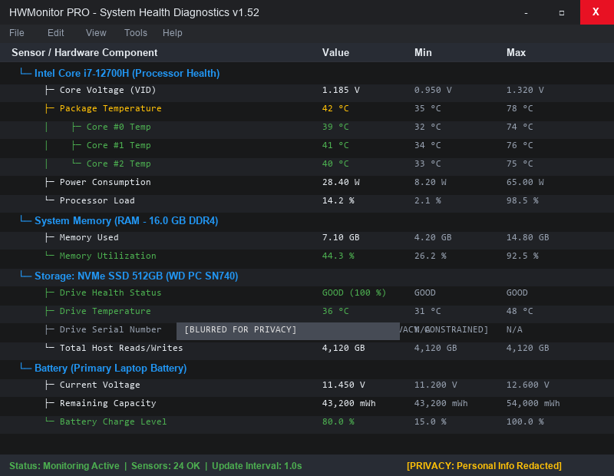
Figure 1: HWMonitor System Health Dashboard (Personal Data Blurred)
4. Compare the use of a multimeter, POST card, and software diagnostics by creating a table with three columns (Tool, What it checks, Example Problem Detected) and fill in at least one example for each tool.
Answer:
Tool | What it checks | Example Problem Detected
Multimeter | Physical electrical properties including DC/AC voltage, electrical continuity, resistance, and current flow across circuit board components. | Detects a short circuit (0 ohms resistance to ground) on a motherboard's 19V power line caused by a damaged capacitor.
POST Card | Hexadecimal status/error codes output by the BIOS during the Power-On Self-Test process prior to video initialization or OS boot. | Identifies a memory initialization error (Code "C1" or "55") caused by unseated, damaged, or incompatible RAM sticks.
Software Diagnostics  (HWMonitor / CrystalDiskInfo) | Real-time sensor telemetry, S.M.A.R.T. drive logs, fan speeds, CPU/GPU temperatures, voltages, and memory utilization inside the OS. | Detects CPU thermal throttling (temperatures hitting 95°C+) due to dried thermal paste, or drive failure warnings (bad sectors).

